Annual Sandy Springs “Teachers of the Year” Program
The Rotary Club of Sandy Springs on Monday recognized the 2014-15 Sandy Springs Teachers of the Year. The ceremony, an annual event hosted by Rotarians, was held during the club’s lunch program May 18 at Hilton Perimeter Suites. Teachers were chosen by their respective schools. Special guest was Fulton County Area Superintendent Gonzalo La Cava, seen pictured with North Springs Principal Eddie Ruiz, a member of the Rotary Club of Sandy Springs. This year’s winners were:
- Dunwoody Springs Elementary School: Kim Wood
- Heards Ferry Elementary School: Lane Snead
- High Point Elementary School: Tashika Truesdale
- Ison Springs Elementary School: Nick Thompson
- Lake Forrest Elementary School: Jennifer Rivers
- Spalding Drive Charter Elementary School: Tiffany Waller
- Woodland Elementary School: Jessica Foltz
- Ridgeview Charter Middle School: C. Brian Davis
- Sandy Springs Charter Middle School: Latrease Turlington
- North Springs Charter High School: Eric Smith
- Riverwood International Charter High School: Brittany Wood
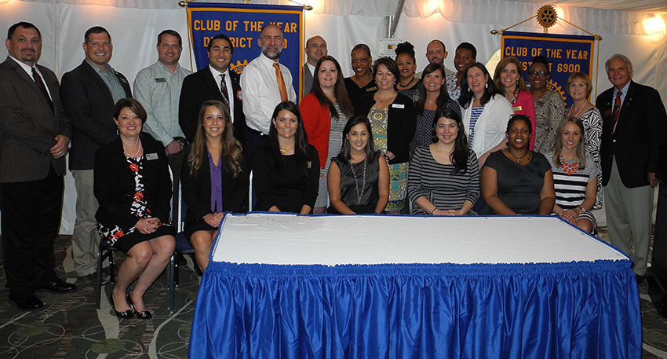
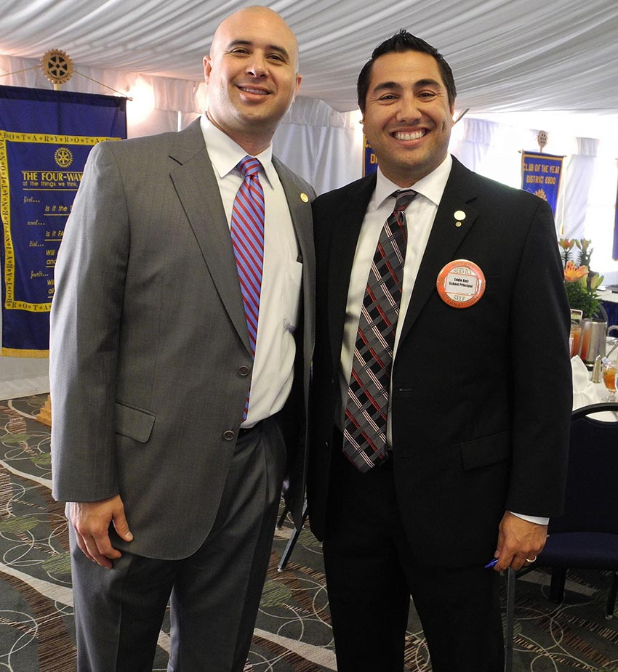
Photo: Back row, from left to right: Riverwood International Charter High School Principal Robert Shaw, Lake Forrest Elementary School Principal Harvey Oaxaca, Ridgeview Charter Middle School Teacher of the Year C. Brian Davis, North Springs Charter High School Principal Eddie Ruiz, North Springs Charter High School Teacher of the Year Eric Smith, Fulton County Area Superintendent Gonzalo La Cava, Dunwoody Springs Elementary School Principal Jennifer Sanders, Ison Springs Elementary School Principal Sara White, Ison Springs Elementary School Teacher of the YearNick Thompson, High Point Elementary School Teacher of the Year Tashika Truesdale; middle row, left to right, Spalding Drive Charter Elementary School Teacher of the YearTiffany Waller, Spalding Drive Charter Elementary School Principal Lynn Johnson, High Point Elementary School Principal Carrie Pitchford, Woodland Elementary School Staff member Elizabeth Sapp, Sandy Springs Charter Middle School Principal Emily Massey, Fulton County School Board Member Julia Bernath, Rotary Club of Sandy Springs President Gene Jordan; and front row, left to right, Ridgeview Charter Middle School Principal Lisa Hastey, Riverwood International Charter High School Teacher of the Year Brittany Wood, Lake Forrest Elementary School Teacher of the Year Jennifer Rivers, Dunwoody Springs Elementary School Teacher of the Year Kim Wood, Woodland Elementary School Teacher of the Year Jessica Foltz, Sandy Springs Charter Elementary School Teacher of the Year Latrease Turlington, Heards Ferry Elementary School Teacher of the Year Lane Snead. Credit: Rotary Club of Sandy Springs

